Physics: Chapter 1 Test Study Guide

- What is physics? What is the goal of physics?
Physics is the study of the fundamental laws of nature.
The goal of physics is to gain a deeper understanding of the world in which we live.
- What are the standard units for length, mass, time, and volume?
L= m, M= kg, t= s, and V= L (cm³)

- Know table 1.4. This is the table with the common prefixes.
P. 18 Know from 10⁹ to 10⁻⁹
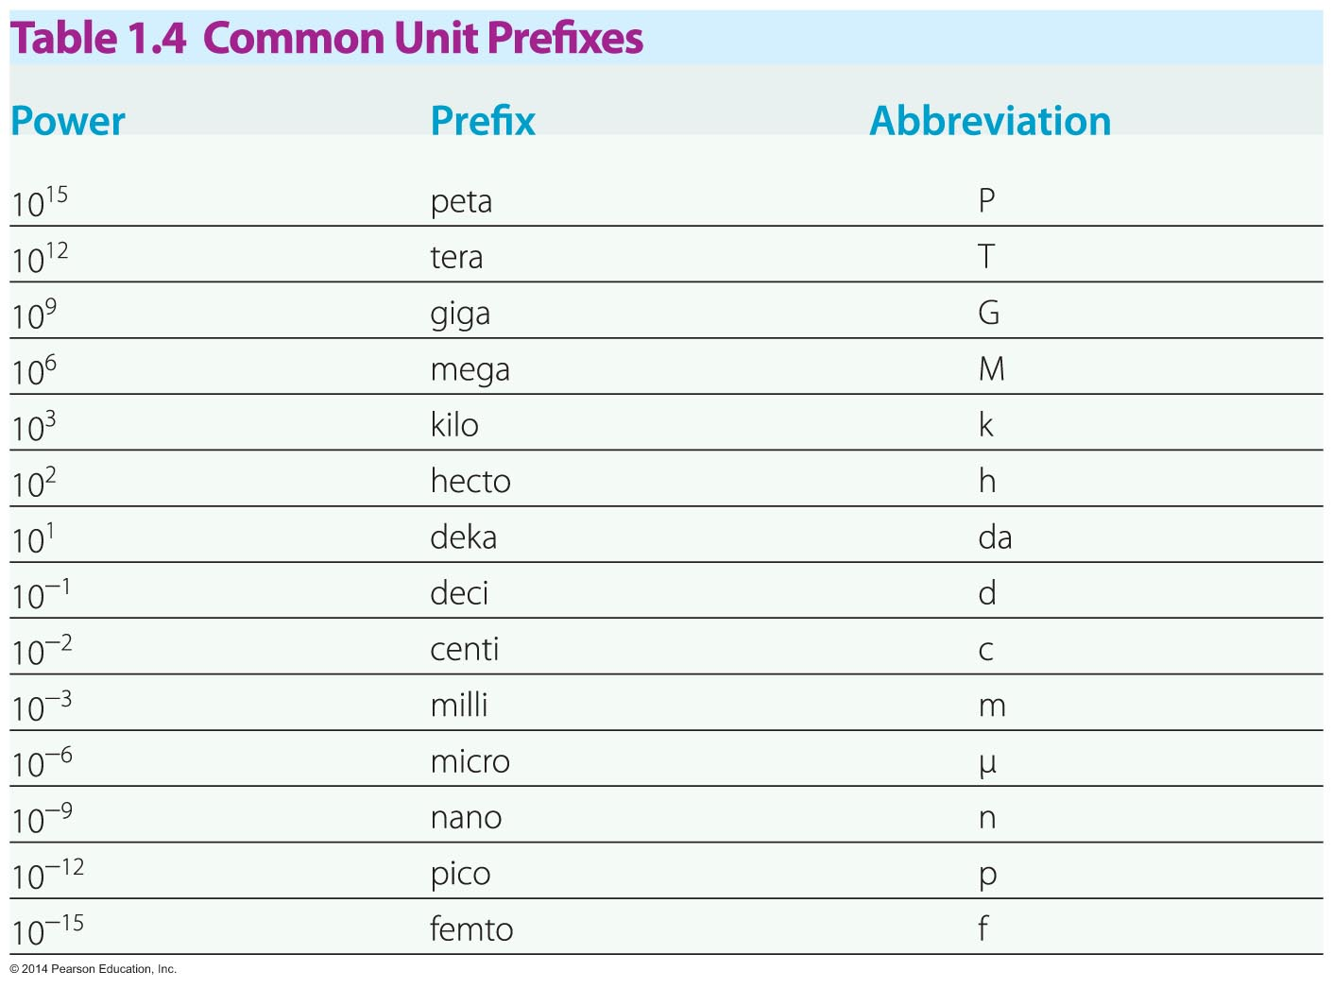

- Know what dimension is being measured by the units being used. (Example: what is measured when you see m²)
M= length
M²= Area
M³= Volume
m/s= Speed
m/s²= Acceleration

In the equation S=a * M, the units for S=m⁴/t and the units for a= m³. What would the units be for M? M=m/t

- When adding scalars do the units need to be the same? Subtracting? Multiplying? Dividing?
When adding and subtracting they do. Not multiplying or dividing

- Be able to do dimensional analysis. Don’t forget to label the units.
  - Convert 17kg to mg- 1.7 x 10⁷ mg
  - Convert 8 miles to km- 10 km (is actually 12.87, proper sig figs)
  - Convert 4 meters to feet- 10 (13.12)
  - Convert 18 m/s to miles/hour- 40. mi/h
- Be able to identify the number of significant figures in a number
  - 200- 1
  - 220. -3
  - 1.7 x 10⁴ -2
  - 0.004- 1
  - 17.0005 -6
- Be able to do math operations resulting in the proper answer with the correct number of significant figures.
  - (1.7)(3.44)= 5.8
  - (3.24) / (1.774)= 1.83
  - (4.2) + (4.75)= 9.0
  - (8.994) – (4.12) = 4.87
In the equation A*B*C, A has 4 sf, b has 3 sf, and C has 5 sf. How many sig figs should your answer have?

- Be able to make estimates using order-of-magnitude.
  - What is the height of an average male in cm?
About 200 cm (2m)

- Be able to write numbers in scientific notation. Be able to write numbers in scientific notation out.
Be able to compare numbers (Which is larger). These are multiple choice questions.

- You will need to know how to use the Pythagorean theorem for one problem.
  - a² + b² = c²
You will be given the dimensions of a garden. You need to figure out what the length of the diagonal will be, to the proper number of sig figs.
Express the sum of 2.10 kg + 1578 g + 3.11 x 10⁴ mg in the correct number of sig figs.
2.10 kg + 1.578 kg + 0.0311 kg (When adding look at decimal places only)
= 3.7091 kg (we need 2 sig figs in the decimal portion of the answer)
= 3.71 kg

The rate at which something moves is R = a * t. If R is measured in the units m³/s, and time t is measured in seconds, what are the SI units for a?
Solve for a
a= R/t
Put in the units for R and t
$\frac{m3/s }{s}$ = $\frac{m3}{s^{2}}$

